## 4.2 Installing Driver on Windows

Before using the KEYESTUDUO Mega plus control board, you must install the driver of it, otherwise it will not communicate with computer.

Unlike the USB series chip (ATMEGA8U2) of the Arduino UNO R3, the KEYESTUDIO Mega plus development board is used the CP2102 chip USB series chip and USB type C interface.

The driver of the CP2102 chip is included in 1.8.0 version and newer version of Arduino IDE. Usually, you connect the board to the computer and wait for Windows to begin its driver installation process. After a few moments, the process will succeed.

If the driver installation process fail, you need to install the driver manually.

Note:

1. Please make sure that your IDE is updated to 1.8.0 or newer version

2.If the version of Arduino IDE you download is below 1.8, you should download the driver of CP2102 and install it manually.

Link to download the driver of CP2102:

**<https://fs.keyestudio.com/CP2102-WIN>**

To install the drive manually, open the device manager of computer.

Right click Computer----- Click Properties-----Click Device Manager.

Look under Ports (COM & LPT) or other device.

A yellow exclamation mark means that the CP2102 driver installation failed.

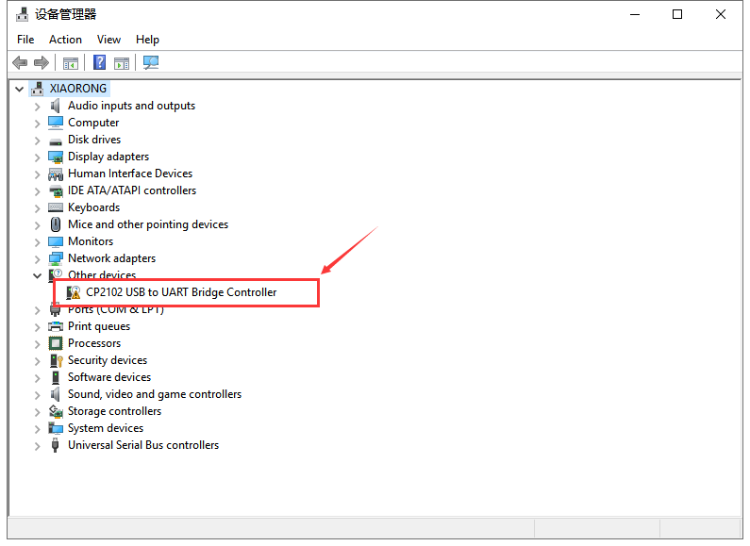

Double-click the font with yellow exclamation mark and clich “OK”

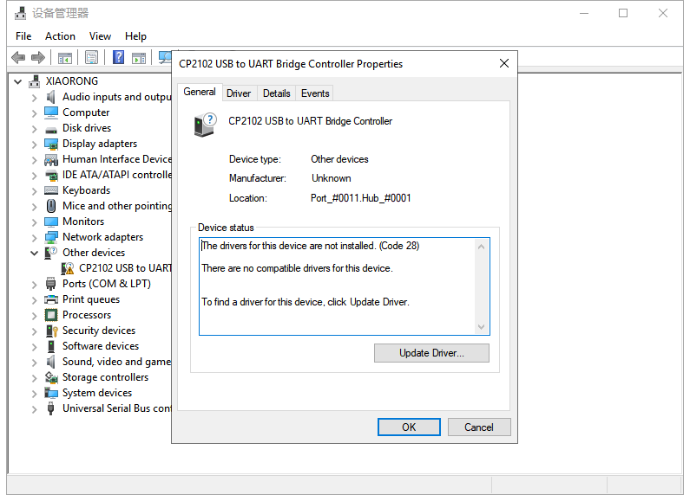

Click “browse my computer for updated driver software”.

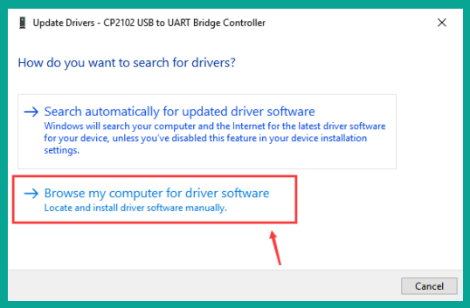

Navigate to the "Drivers" folder of the Arduino Software you have download and click “Next” to install the drive.

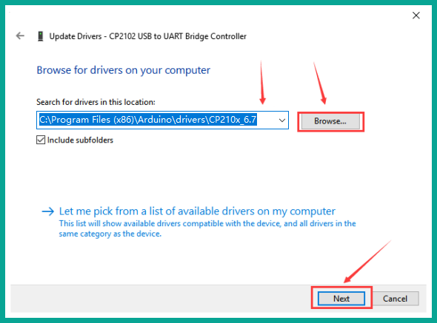

The driver is installed successfully.

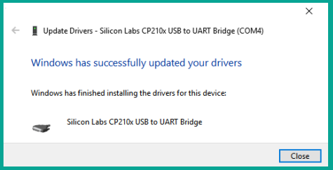

Open device manager, we will find the yellow exclamation mark disappear. The driver of CP2102 is installed successfully.

